SQA Assignment 1

**Problem 1**

1.

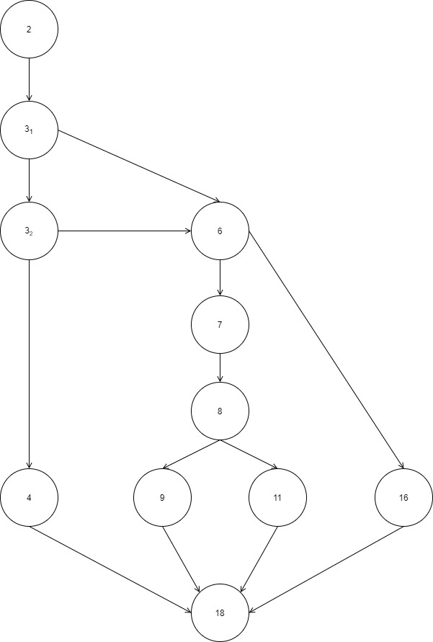

2. Cyclomatic number = # of regions in the flow graph = 5

Cyclomatic number = # of conditions in the flow graph + 1 = 4 + 1 = 5

Cyclomatic number = # of edges - # of nodes + 2 = 14 – 11 + 2 = 5

3. P* = 5

**Problem 2**

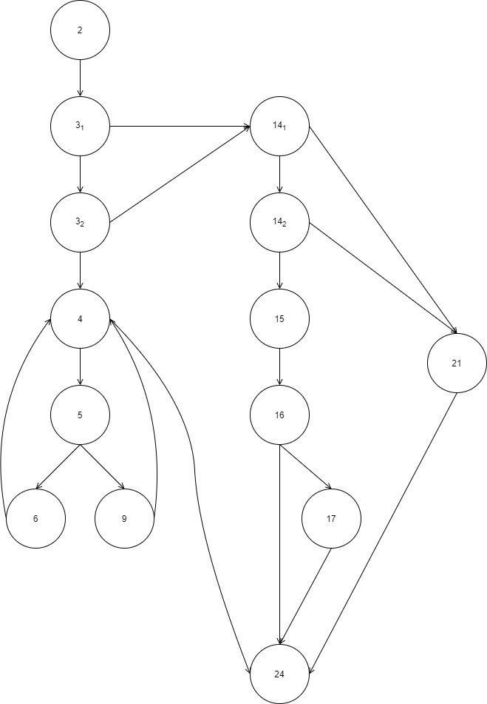1.

2. Cyclomatic number = # of regions in the flow graph = 8

Cyclomatic number = # of conditions in the flow graph + 1 = 7 + 1 = 8

Cyclomatic number = # of edges - # of nodes + 2 = 20 – 14 + 2 = 8

3. P* = 8

**Problem 3**

1.

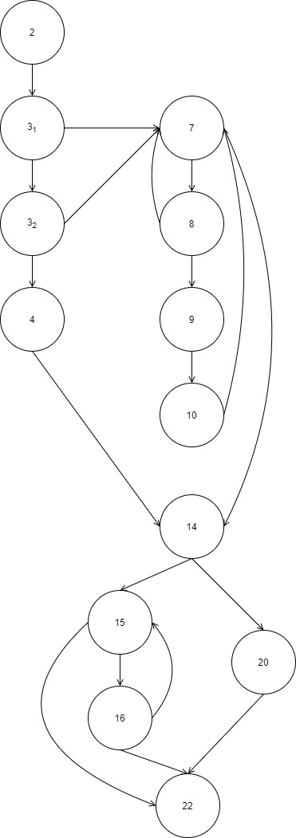

2. Cyclomatic number = # of regions in the flow graph = 7

Cyclomatic number = # of conditions in the flow graph + 1 = 6 + 1 = 7

Cyclomatic number = # of edges - # of nodes + 2 = 18 – 13 + 2 = 7

3. P* = 7

**Problem 4**

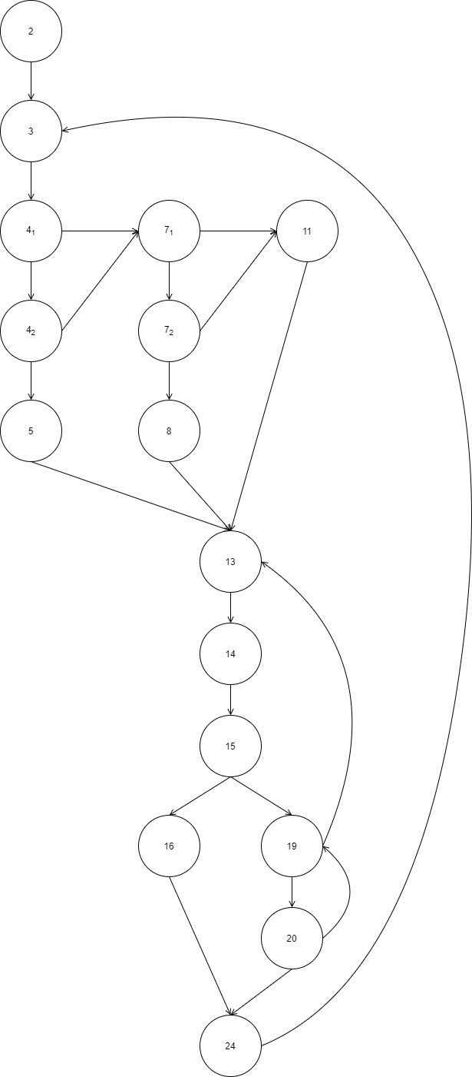1.

2. Cyclomatic number = # of regions in the flow graph = 9

Cyclomatic number = # of conditions in the flow graph + 1 = 8 + 1 = 9

Cyclomatic number = # of edges - # of nodes + 2 = 23 – 16 + 2 = 9

3. P* = 9